The AI-Accelerated Java Engineer Sprint: From TDD to Cloud Deployment

Introduction
Welcome to your intensive 10-day training sprint. This plan is designed to transform you into a job-ready, cloud-native Java engineer.
The Goal: The objective isn't just to learn about Spring Boot, Kafka, AWS, and Jenkins; it's to build, test, and deploy a high-quality, event-driven microservices system that precisely matches the skills required for your target role.
This plan introduces a modern workflow, integrating Test-Driven Development (TDD) with Generative AI as your full-time pair programmer. You will learn to use AI to write failing tests, generate passing code, create complex configurations (like docker-compose and Jenkinsfile), and debug your cloud deployments.
By the end of this sprint, you will have a complete, portfolio-ready project and the hands-on experience to confidently demonstrate your skills in the entire software delivery lifecycle.
Contents
Introduction 1
🌟 The "Golden Rules" for Working with AI 2
💻 The Micro-Project: "Event-Driven Onboarding System" 2
🚀 The 10-Day AI-Assisted TDD Sprint 3
Module 1: Core Service & TDD (Days 1-3) 3
Module 2: Integration & Events (Days 4-6) 4
Module 3: Cloud Delivery & Automation (Days 7-10) 6
Architecture Diagrams 7

🌟 The "Golden Rules" for Working with AI
Before you start, you must adopt this new workflow.
- You are the Architect, AI is the Pair Programmer. You make the decisions. The AI writes the code. You are responsible for reviewing, testing, and integrating every line.
- Use the AI-TDD Loop (Red-Green-Refactor): This is your new development cycle.
  - [Red]: Prompt the AI: "Write a failing JUnit 5 test for [this behavior]." You run the test and watch it fail.
  - [Green]: Prompt the AI: "Here is my failing test. Write the minimum code in [this class] to make it pass." You run the test and watch it pass.
  - [Refactor]: Prompt the AI: "This code passes, but it's not clean. Can you refactor it?"
- Context is King: Don't just say "it's broken." Give the AI context. "Here is my UserService.java, my UserServiceTest.java, and the exact error log from mvn test. Why is the test failing?"
- AI Excels at Boilerplate: Your biggest time-saver will be config files. Always ask the AI to generate the first draft of your pom.xml, Dockerfile, docker-compose.yml, Jenkinsfile, and AWS JSON/YAML.

💻 The Micro-Project: "Event-Driven Onboarding System"
You will build a full system that simulates a new user signing up, being saved, having a profile created, and getting a notification.
- user-api-service (Spring Boot): A REST API for creating users. It saves to MongoDB and publishes a UserCreatedEvent to Apache Kafka.
- profile-api-service (Spring Boot): A second service with an API. It creates an empty user profile in DynamoDB.
- notification-service (AWS Lambda): A consumer that listens to the Kafka topic. On receiving an event, it calls the profile-api-service to create the profile and logs a "Welcome!" message to CloudWatch (simulating an email).
- Pipeline (Jenkins/Docker/AWS): The whole system will be containerized in Docker and deployed automatically to AWS ECS and Lambda via a Jenkins pipeline.

🚀 The 10-Day AI-Assisted TDD Sprint
This is an intensive sprint. Each day builds on the last.

Module 1: Core Service & TDD (Days 1-3)
Goal: Build the primary user-api-service using a strict TDD workflow.
- Day 1: Project Setup & TDD
  - Technical Goal: Create the user-api-service project.
  - AI-Assisted Tasks:
    - Prompt (Learn): "Explain the Red-Green-Refactor cycle in Test-Driven Development."
    - Prompt (Generate): "Generate a pom.xml for a Java 17 Spring Boot project. Include dependencies for spring-boot-starter-web, spring-boot-starter-data-mongodb, spring-kafka, and spring-boot-starter-test (with JUnit 5)."
    - [Red] Prompt: "Write a failing JUnit 5 test class, UserControllerTest. It should use @WebMvcTest and MockMvc. Write one test, whenPostUser_thenReturns201Created, that mocks a POST to /users with a JSON payload and expects a 201 status."
    - Your Job: Run mvn test. Watch it fail.
- Day 2: TDD the Service Layer
  - Technical Goal: Implement the Controller and Service layers.
  - AI-Assisted Tasks:
    - [Green] Prompt: "My UserControllerTest is failing. Write the UserController class with a POST /users endpoint to make it pass. It should call a UserService."
    - Your Job: Run mvn test. It will now complain about the missing UserService.
    - [Red] Prompt: "Update UserControllerTest to use @MockBean for UserService. Verify the createUser method is called. Now, write a new test class, UserServiceTest, to unit-test UserService. It should mock the UserRepository. Write a test, whenCreateUser_shouldSaveToRepository, that verifies the repository.save() method is called."
    - [Green] Prompt: "My UserServiceTest is failing. Write the UserService implementation to make it pass."
- Day 3: TDD the Database Layer (Testcontainers)
  - Technical Goal: Write an integration test for the MongoDB repository.
  - AI-Assisted Tasks:
    - Prompt (Generate): "Add the org.testcontainers:mongodb dependency to my pom.xml."
    - [Red] Prompt: "Write a new integration test class, UserRepositoryTest. It must use @DataMongoTest and @Testcontainers. It needs to start a real MongoDB container. Write a test that saves a User entity, then fetches it by ID, and asserts the username matches."
    - [Green] Prompt: "My test is failing. Write the UserRepository interface (extending MongoRepository) and the User entity class (@Document) to make it pass."

Module 2: Integration & Events (Days 4-6)
Goal: Connect your services with Kafka and build the other services using TDD.
- Day 4: TDD the Kafka Producer
  - Technical Goal: Make the user-api-service publish an event when a user is created.
  - AI-Assisted Tasks:
    - Prompt (Generate): "Add the spring-kafka-test dependency to my pom.xml."
    - [Red] Prompt: "I need to test my Kafka producer. Write an integration test for my UserService using @SpringBootTest and @EmbeddedKafka. It should call userService.createUser(). Then, it must consume from the user-created-topic and assert that the correct user's email was received."
    - [Green] Prompt: "My test is failing. Modify my UserService to inject KafkaTemplate and send the User object to the user-created-topic after saving to the database. This should make the test pass."
- Day 5: TDD the profile-api-service (DynamoDB)
  - Technical Goal: Build the second microservice (profile-api-service) that writes to DynamoDB.
  - AI-Assisted Tasks (Repeat the TDD pattern):
    - Prompt (Generate): "Generate a pom.xml for a new Spring Boot service with web, spring-data-dynamodb (or the AWS SDK v2), and testcontainers with the dynamodb-local image."
    - [Red] Prompt: "Write an integration test for my ProfileRepository using @SpringBootTest and @Testcontainers with a DynamoDB-local container. The test should save a UserProfile and then retrieve it to verify it was saved."
    - [Green] Prompt: "Write the ProfileRepository and UserProfile entity (with DynamoDB annotations) to make this test pass."
    - Your Job: Use the prompts from Day 2 to TDD the ProfileController and ProfileService for this new service.
- Day 6: TDD the notification-service (Lambda)
  - Technical Goal: Build the Lambda function that consumes Kafka events.
  - AI-Assisted Tasks:
    - Prompt (Generate): "Generate a pom.xml for a Java 17 AWS Lambda function. Include dependencies for aws-lambda-java-core, aws-lambda-java-events (for Kafka), and JUnit 5."
    - [Red] Prompt: "Write a JUnit 5 test for my NotificationHandler class. It must mock the KafkaEvent and the Lambda Context (including the ContextLogger). The test should create a fake KafkaEvent and verify that my handler's log method is called."
    - [Green] Prompt: "My test is failing. Write the NotificationHandler class (implementing RequestHandler<KafkaEvent, Void>) to make it pass. It should just log the messages for now."

Module 3: Cloud Delivery & Automation (Days 7-10)
Goal: Containerize, deploy, and automate the entire system.
- Day 7: Containerize & Connect (Docker)
  - Technical Goal: Get all services running locally in Docker.
  - AI-Assisted Tasks:
    - Prompt (Generate): "Write a multi-stage Dockerfile for my user-api-service Maven project." (Repeat for profile-api-service).
    - Prompt (Generate): "Write a docker-compose.yml file to run my entire system: user-api, profile-api, mongodb, and kafka with zookeeper. The services must be able to communicate with each other."
    - Your Job (Debug): This will fail. Your app will say localhost:9092 (Connection Refused).
    - Prompt (Debug): "My Spring Boot app in Docker can't connect to Kafka at localhost:9092. Here is my docker-compose.yml. How do I fix the networking?"
    - (AI will explain Docker networking and tell you to use the service name, e.g., kafka:9092).
- Day 8: AWS Setup (The "ClickOps" Day)
  - Technical Goal: Manually create the cloud infrastructure.
  - AI-Assisted Tasks:
    - Prompt (Learn): "What steps do I need to follow to deploy a Docker container to AWS ECS Fargate?"
    - Prompt (Learn): "How do I create an AWS Lambda function and configure a Kafka (Amazon MSK) trigger?"
    - Your Job: Use the AWS console to create: 1) An ECR repository for your images. 2) A DynamoDB table. 3) An ECS Cluster with a Service/Task Definition. 4) An S3 bucket (for a bonus task). 5) An AWS Lambda function.
- Day 9: CI/CD with Jenkins (Part 1: Test & Build)
  - Technical Goal: Create a Jenkins pipeline that builds and tests everything.
  - AI-Assisted Tasks:
    - Prompt (Generate): "Write a declarative Jenkinsfile with parallel stages.
      - Stage 1: 'Checkout' (Git).
      - Stage 2 (Parallel):
        - 'Build & Test user-api' (runs mvn -f user-api-service/pom.xml clean install).
        - 'Build & Test profile-api' (runs mvn -f profile-api-service/pom.xml clean install).
      - The entire pipeline must fail if any test fails."
- Day 10: CI/CD & Full System Test (Part 2: Deploy)
  - Technical Goal: Enhance the pipeline to deploy to AWS.
  - AI-Assisted Tasks:
    - Prompt (Generate): "Add stages to my Jenkinsfile. After the 'Test' stages pass:
      - 'Build Images' (Parallel): Build the Docker images for user-api and profile-api.
      - 'Push to ECR': Push both images to my AWS ECR repository. (How do I handle AWS credentials in Jenkins?)
      - 'Deploy': Use the AWS CLI to update my ECS service (aws ecs update-service) and deploy my Lambda function."
    - Your Job: Run the pipeline. Test the live user-api endpoint. Create a user. Go to CloudWatch and see the log from your Lambda. Go to DynamoDB and see the new profile. You have now completed the entire project.

Architecture Diagrams
Here are the architecture diagrams for the application at its key training stages.

1. Stage 1: Core Service TDD (Days 1-3)
At this stage, everything is local. The focus is on unit and integration testing the user-api-service in isolation before even containerizing it. The key is using Testcontainers to spin up a real, temporary database just for the test.
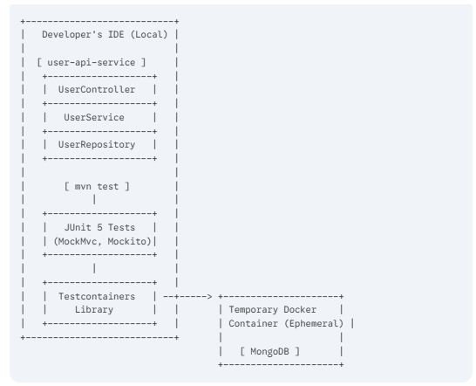

- Flow: The mvn test command runs your JUnit tests.
  - Unit Tests (like UserControllerTest) use Mockito to mock dependencies (like UserService).
  - Integration Tests (like UserRepositoryTest) use the Testcontainers library to start a real MongoDB database in a temporary Docker container. The test runs against this real database and then the container is destroyed.

2. Stage 2: Full System Integration (Days 4-7)
This is the local, end-to-end system. All services are running as containers on your machine, orchestrated by docker-compose. This simulates the cloud environment locally.
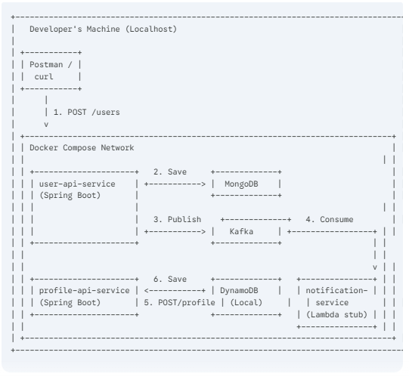
- Flow:
  - You (the developer) send a request from Postman to the user-api-service.
  - The user-api saves the user to the MongoDB container.
  - The user-api publishes a message to the Kafka container.
  - Your Lambda (running as a simple Java app or test consumer) polls Kafka.
  - The Lambda calls the profile-api-service.
  - The profile-api saves the new profile to the DynamoDB-local container.

3. Stage 3: Final Cloud Deployment (Days 8-10)
This is the final, production-like architecture deployed on AWS. Jenkins automates the deployment, and managed AWS services replace your local containers.
Part A: The CI/CD Pipeline Flow
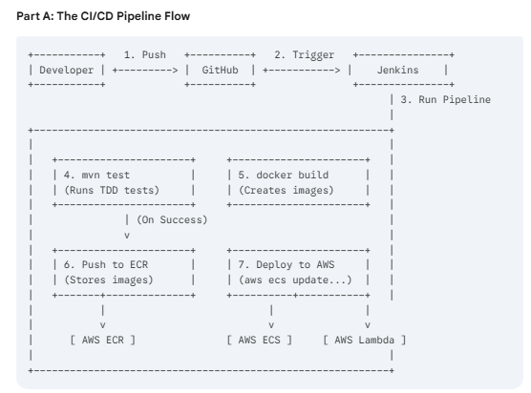
Part B: The Deployed Application Flow
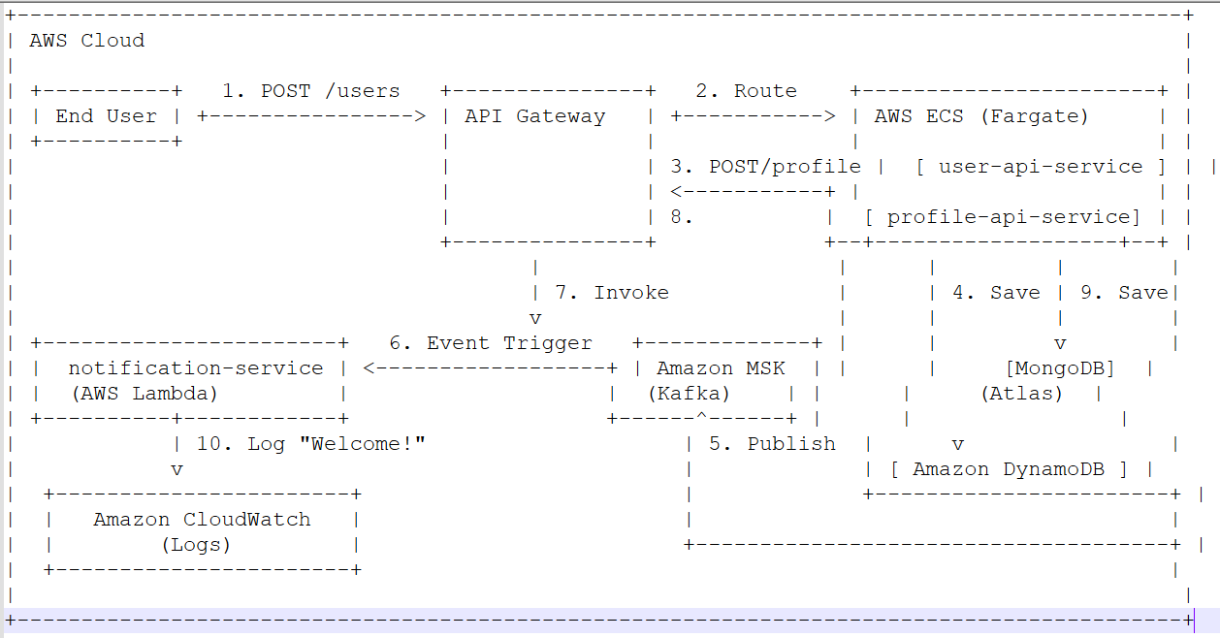
- Flow:
  - An End User calls the POST /users endpoint via API Gateway.
  - API Gateway routes the request to the user-api-service running in AWS ECS.
  - (This path is for the second service call)
  - The user-api saves the user to MongoDB Atlas (a managed, external database).
  - The user-api publishes the UserCreatedEvent to Amazon MSK (managed Kafka).
  - MSK triggers the notification-service Lambda function.
  - The Lambda function gets the event.
  - The Lambda also calls API Gateway to hit the POST /profile endpoint on the profile-api-service (also in ECS).
  - The profile-api saves the new profile to the managed Amazon DynamoDB table.
  - The Lambda writes a log message to Amazon CloudWatch, completing the flow.

